Fall Spirit Wear Order
Fall Spirit Wear this year includes long sleeve black or pink t-shirts with “Columbia Elementary Astros” on the front pocket and the school motto “Always Striving to Reach Our Stars” on the back.
Please return order form and payment no later than October 6th. Make checks payable to CES PTA. Any orders received after the deadline cannot be guaranteed! Please indicate the number of each size you would like below:
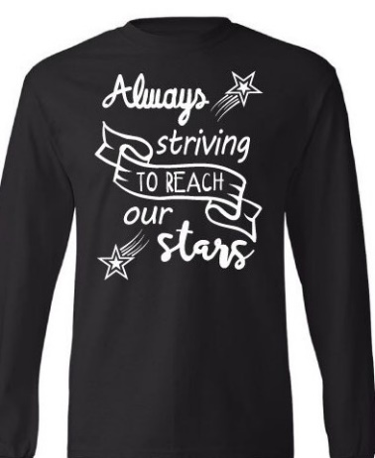
Black Long sleeve t-shirt:
Youth Adult
XS @ $15 S @ $15
S _________@ $15 M________@ $15
M @ $15 L @ $15
L _________@ $15 XL __ @ $15

XL @ $15 2XL________@ $17

3XL ________@ $21
Pink Long sleeve t- shirt:
Youth Adult
XS @ $15 S @ $15
S _________@ $15 M ______@ $15
M @ $15 L_ @ $15
L _________@ $15 XL___ @ $15

XL @ $15 2XL _______@ $17

3XL _______@ $17
Number of Youth shirts - __________________ Number of Adult Shirts - ___________________
Total Amount due: $______________________________________________________________
Student Name(s): _______________________________________________________________
Teacher’s Name: _______________________________________________________________

Office Use: Received by: _________________________ Date received: Cash ________ or Check # _________________

